**Lab 3 Solutions**

**Name**: Kaushik Raj V Nadar

**Roll No**.: 208160499

**Date**: 13/08/2024

**Part 1**

**Code:**

library(Matrix)

y = c(1, 4, 8, 9, 3, 8, 9)

x1 = c(-1, 1, -1, 1, 0, 0, 0)

x2 = c(-1, -1, 1, 1, 0, 1, 2)

A = matrix(c(1,0,0,1,0,-1,0,0),nrow=2)

q = rankMatrix(A)[1]

C = rep(0,2)

model = summary(lm(y~x1+x2+I(x1^2)))

n = length(y)

p = 4

X = cbind(1,x1,x2,x1^2)

beta = model$coefficients[,1]

beta

rss_rssh = t(A%*%beta)%*%solve(A%*%solve(t(X)%*%(X))%*%t(A))%*%A%*%beta

rss_rssh

RSS = t(y-X%*%beta)%*%(y-X%*%beta)

f.stat= ((rss_rssh)/q)/(RSS/(n-p))

f.stat

**Output:**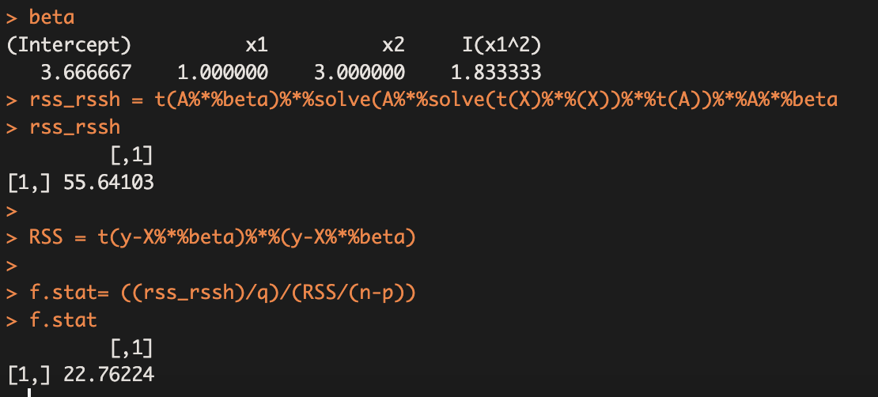

**Part 2**

**Code**:

# Load necessary packages

library(car)

# Step 1: Prepare the data

y = c(1, 4, 8, 9, 3, 8, 9)

x1 = c(-1, 1, -1, 1, 0, 0, 0)

x2 = c(-1, -1, 1, 1, 0, 1, 2)

A = matrix(c(1,0,0,1,0,-1,0,0),nrow=2)

# Step 2: Fit the regression model

model <- lm(y ~ x1 + x2 + I(x1^2))

# Step 3: Test the hypotheses

# Test H0: beta0 = 0 and beta1 - beta2 = 0

linearHypothesis(model, hypothesis.matrix = A)

**Output**:

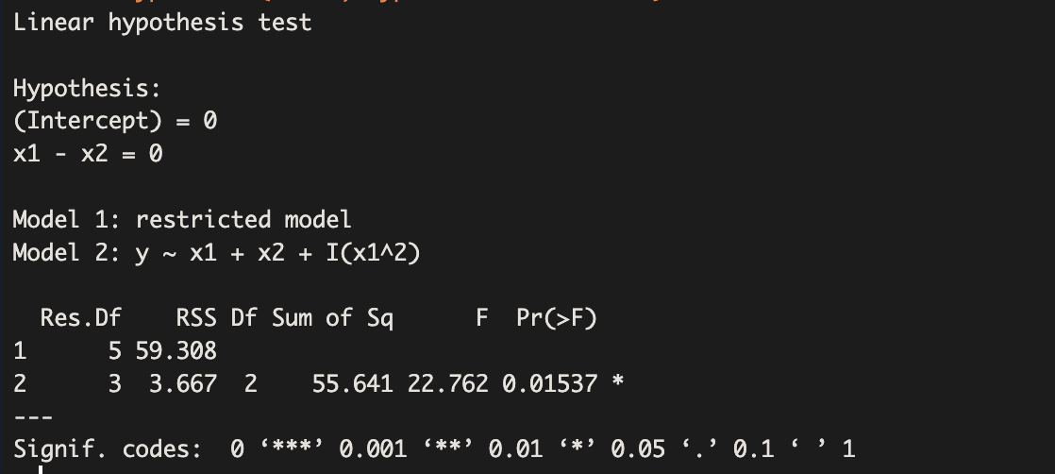

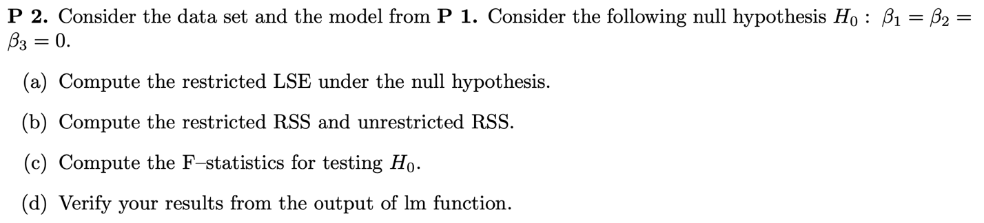

**Code**:

# Data

y <- c(1, 4, 8, 9, 3, 8, 9)

x1 <- c(-1, 1, -1, 1, 0, 0, 0)

x2 <- c(-1, -1, 1, 1, 0, 1, 2)

# (a) Restricted LSE under H0

Beta0_hat_restricted <- mean(y)

cat("Restricted LSE for β0 under H0:", Beta0_hat_restricted, "\n")

# (b) Restricted RSS

RSS_restricted <- sum((y - Beta0_hat_restricted)^2)

cat("Restricted RSS:", RSS_restricted, "\n")

# Unrestricted model

X <- cbind(1, x1, x2, x1^2)

Beta_hat_unrestricted <- solve(t(X) %*% X) %*% t(X) %*% y

# Unrestricted RSS

RSS_unrestricted <- sum((y - X %*% Beta_hat_unrestricted)^2)

cat("Unrestricted RSS:", RSS_unrestricted, "\n")

# (c) Compute the F-statistic

n <- length(y)

p <- ncol(X)

q <- 3 # Number of restrictions

F_statistic <- ((RSS_restricted - RSS_unrestricted) / q) / (RSS_unrestricted / (n - p))

cat("F-statistic for testing H0:", F_statistic, "\n")

# (d) Verify using lm function

unrestricted_model <- lm(y ~ x1 + x2 + I(x1^2))

summary(unrestricted_model)

# To test the null hypothesis using the anova function

restricted_model <- lm(y ~ 1)

anova(restricted_model, unrestricted_model)

**Output**:

> # (a) Restricted LSE under H0

> Beta0_hat_restricted <- mean(y)

> cat("Restricted LSE for β0 under H0:", Beta0_hat_restricted, "\n")

Restricted LSE for β0 under H0: 6

>

> # (b) Restricted RSS

> RSS_restricted <- sum((y - Beta0_hat_restricted)^2)

> cat("Restricted RSS:", RSS_restricted, "\n")

Restricted RSS: 64

>

> # Unrestricted model

> X <- cbind(1, x1, x2, x1^2)

> Beta_hat_unrestricted <- solve(t(X) %*% X) %*% t(X) %*% y

>

> # Unrestricted RSS

> RSS_unrestricted <- sum((y - X %*% Beta_hat_unrestricted)^2)

> cat("Unrestricted RSS:", RSS_unrestricted, "\n")

Unrestricted RSS: 3.666667

>

> # (c) Compute the F-statistic

> n <- length(y)

> p <- ncol(X)

> q <- 3 # Number of restrictions

>

> F_statistic <- ((RSS_restricted - RSS_unrestricted) / q) / (RSS_unrestricted / (n - p))

> cat("F-statistic for testing H0:", F_statistic, "\n")

F-statistic for testing H0: 16.45455

>

> # (d) Verify using lm function

> unrestricted_model <- lm(y ~ x1 + x2 + I(x1^2))

> summary(unrestricted_model)

Call:

lm(formula = y ~ x1 + x2 + I(x1^2))

Residuals:

1 2 3 4 5 6 7

-0.5000 0.5000 0.5000 -0.5000 -0.6667 1.3333 -0.6667

Coefficients:

Estimate Std. Error t value Pr(>|t|)

(Intercept) 3.6667 0.7817 4.690 0.01832 *

x1 1.0000 0.5528 1.809 0.16815

x2 3.0000 0.4513 6.647 0.00694 **

I(x1^2) 1.8333 0.9574 1.915 0.15140

---

Signif. codes: 0 ‘***’ 0.001 ‘**’ 0.01 ‘*’ 0.05 ‘.’ 0.1 ‘ ’ 1

Residual standard error: 1.106 on 3 degrees of freedom

Multiple R-squared: 0.9427, Adjusted R-squared: 0.8854

F-statistic: 16.45 on 3 and 3 DF, p-value: 0.02288

>

> # To test the null hypothesis using the anova function

> restricted_model <- lm(y ~ 1)

> anova(restricted_model, unrestricted_model)

Analysis of Variance Table

Model 1: y ~ 1

Model 2: y ~ x1 + x2 + I(x1^2)

Res.Df RSS Df Sum of Sq F Pr(>F)

1 6 64.000

2 3 3.667 3 60.333 16.454 0.02288 *

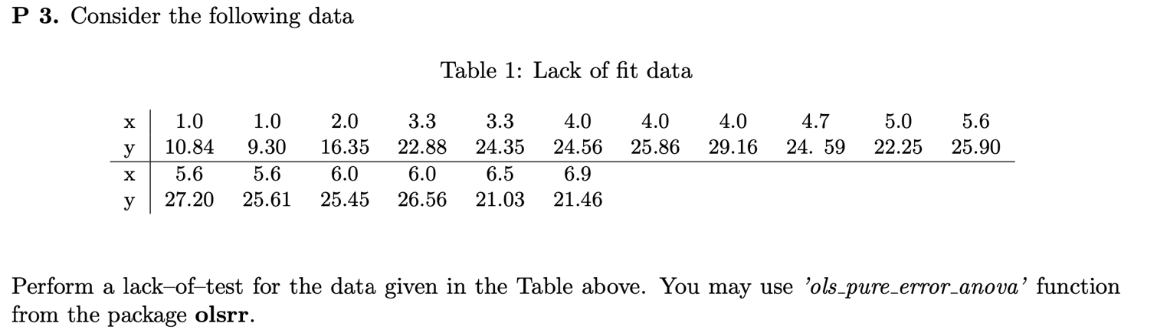

**Code:**

library(olsrr)

# Input the data

x <- c(1.0, 1.0, 2.0, 3.3, 3.3, 4.0, 4.0, 4.0, 5.6, 5.6, 6.0, 6.0, 6.5, 6.9)

y <- c(10.84, 9.30, 16.35, 22.88, 24.35, 24.56, 25.86, 29.16, 27.20, 25.61, 25.45, 26.56, 21.03, 21.46)

# Fit the linear model

model <- lm(y ~ x)

# Perform the lack-of-fit test

lack_of_fit_test <- ols_pure_error_anova(model)

# Print the results

print(lack_of_fit_test)

**Output:**

